Guidance for submitting a project application to Kom op tegen Kanker

1/Login
To open an application for project subsidies via the Kom op tegen Kanker website (http://www.komoptegenkanker.be/steun-aan-onderzoek/steun-aan-onderzoek) login (or register) and follow the instructions.
Further explanation and descriptions of each field can be found below.
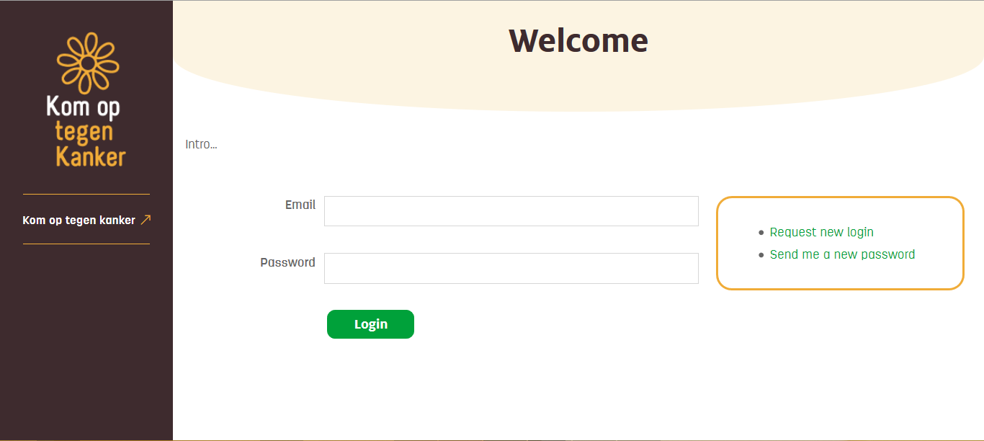
Troubleshooting:
  - I do not yet have a login for Kom op tegen Kanker
If you have not yet created a login, click on “Request new login”. The following screen will appear:
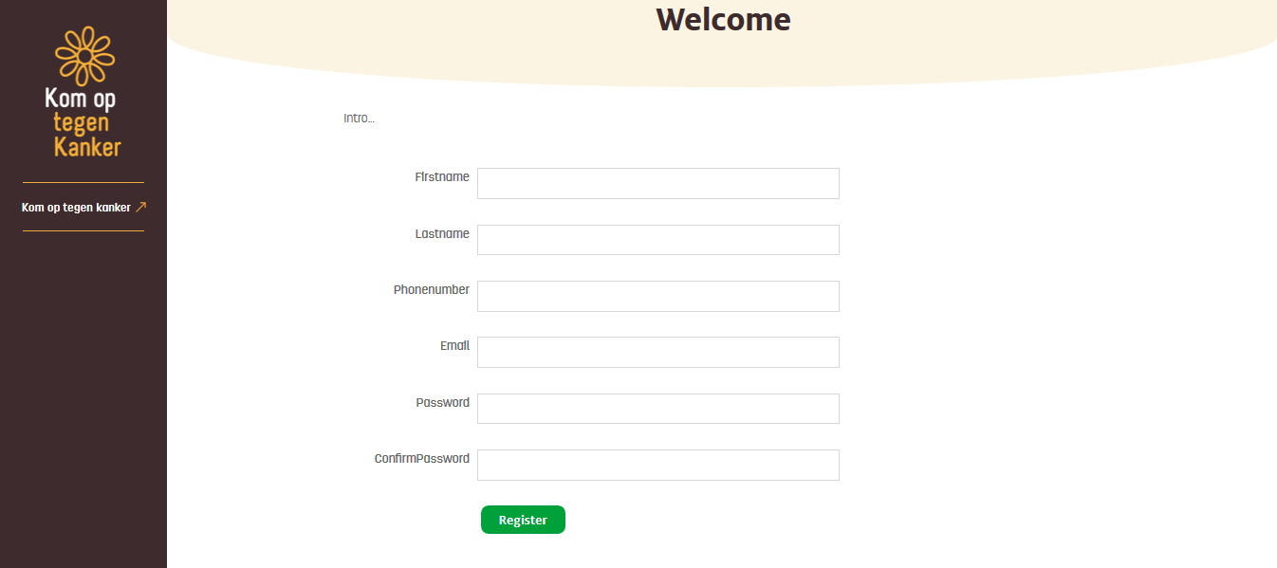

Fields with an * are mandatory in order to register. After you have completed the required information, click on the “Register” button below. You will receive an email confirming your registration. After receiving this email you may log in using the registered email address and the password you supplied by clicking on the “Login” button.

  - I have a login for Kom op tegen Kanker
You may log in using the registered email address and password and clicking on the “Login” button.

  - I have a login for Kom op tegen Kanker but have forgotten my password
If you have already created a login but no longer remember your password, a new one can be requested by clicking on “Send me a new password”. You will an automatically generated password by email. You can then log in using your registered email address and the automatically generated password.
Once logged in you can change your password by clicking on the “My profile” link.

  - My profile
Click on “My profile” in the menu bar on the left-hand side of the screen in order to access your profile. Here you can manage your personal information and change your password at any time.
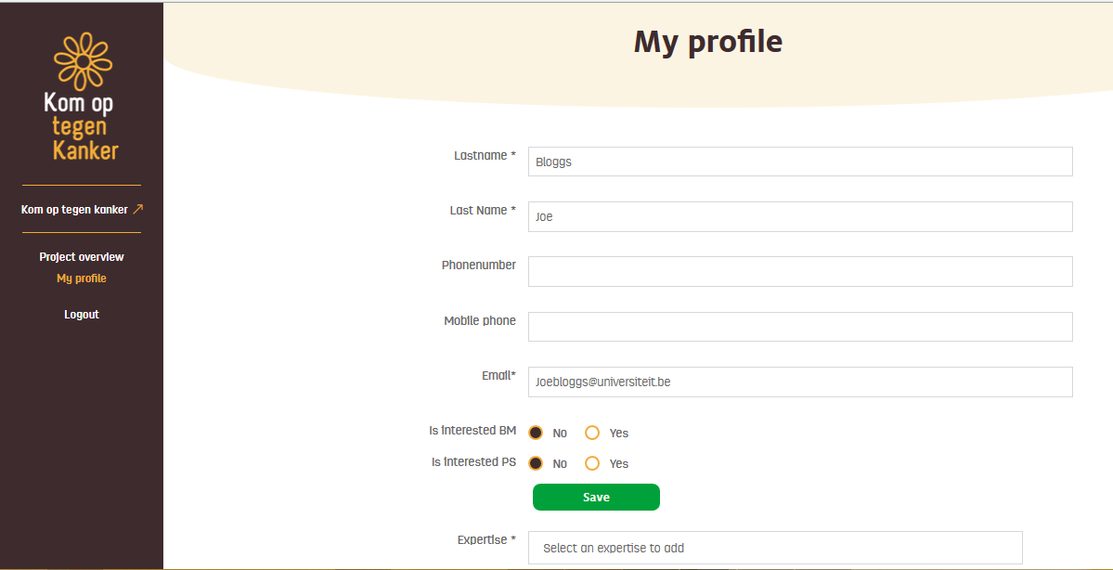
Your first name, last name, email address and expertise are required fields in order to submit an application to Kom op tegen Kanker. If you wish, can also supply contact telephone and mobile phone numbers.
Interested BM: In order to receive emails about project calls and other initiatives in biomedical research from Kom op tegen Kanker, click “Yes” here.
Interested PS: In order to receive emails about project calls and other initiatives in psychosocial and social sciences research from Kom op tegen Kanker, click “Yes” here.
In order to save any new or changed information, click on the “Save” button before leaving the page.
Expertise: Here you are required to indicate your area of (research)expertise. Click in the field and select an area from the list. Once selected click on the green plus sign (+) to the right, your selection will appear below and will automatically be saved. Choices can be removed by clicking on the red cross (x). You may select more than one area of expertise.
In the event that Kom op tegen Kanker launches an initiative in your area of expertise you will be informed and/or may be consulted in an advisory capacity.
If your area of expertise is not on the list, please contact the Kom op tegen Kanker project management coordinator (Ipelemans@komoptegenkanker.be).
Affiliation: Here you may add your institutional affiliation. Click on “Select affiliation” and select one of the options in the drop down list. If your institution/organisation is not available contact the Kom op tegen Kanker project management coordinator (Ipelemans@komoptegenkanker.be). To add further affiliations click on the green plus sign (+) to the right.
Password: to change your password, first enter your old password in the “Old Password” field and enter the new password in the “Password” field. Enter the new password again in the “Confirm Password” field and click on “Save”. You can now log in with the new password.

2/ Submitting an application
Once logged in, an overview of your applications in process (either a (co)applicant/project lead) is available in the Project overview screen.
You can also submit a new application by clicking on the “New Request” button.
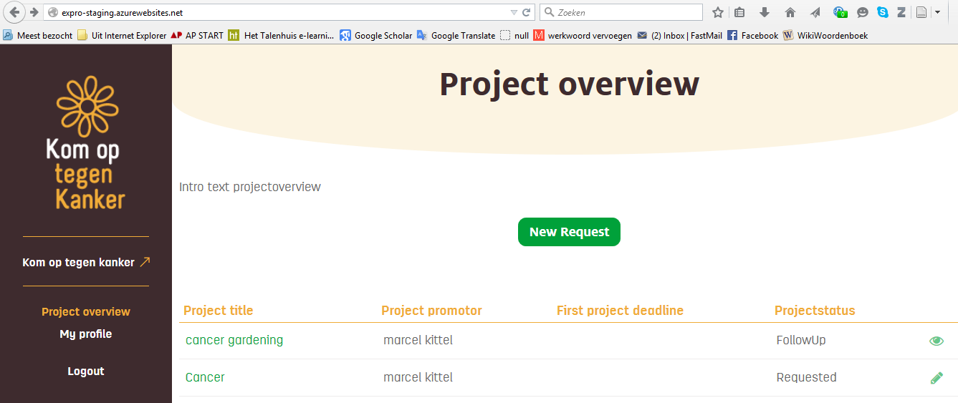
In the New Request screen, project types are listed under the relevant domain, either biomedical or psychosocial/social sciences projects (research projects, bursaries, care projects, etc). Further details about the project types can be found on the Kom op tegen Kanker webpages (for biomedical projects see www.komoptegenkanker.be/onderzoek/biomedisch-onderzoek and psychosocial projects see www.komoptegenkanker.be/psychosociale-onderzoeksprojecten-doe-een-aanvraag-voor-steun). Open calls can also be selected via the list. If your choice is not visible, then it is not currently open and it is not possible to submit an application.
Once you have made your choice, click on the name to select it. The following screen titled ‘Project request’ will appear:
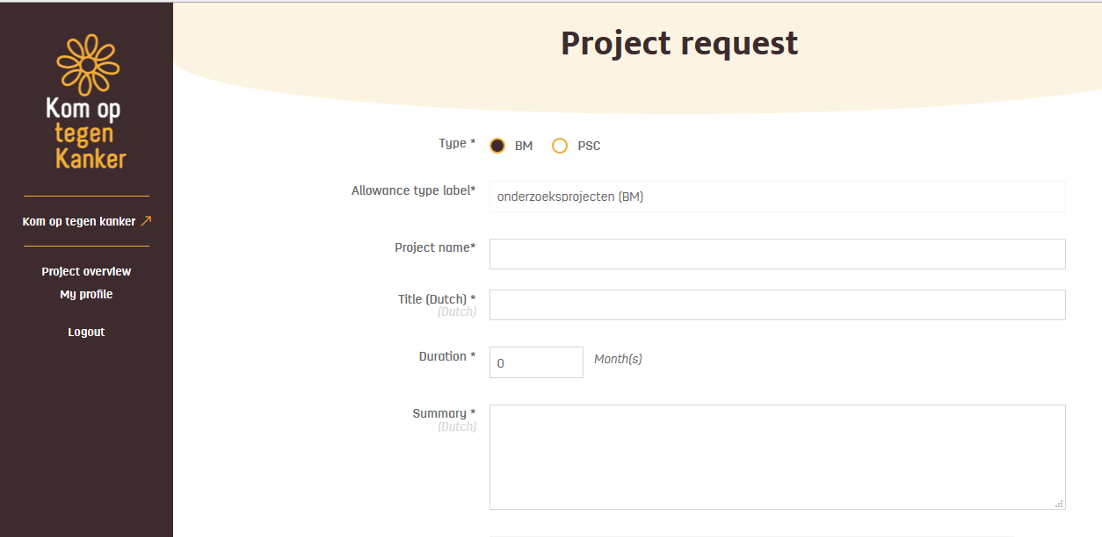
The fields project “type” and “subsidy type label” are automatically completed based on the type of project selected (red circles above).
Further information is now required to complete the project request. All fields marked with an * are mandatory.
Short descriptions of each field:
Project name*: The English title of your project
Title (Dutch)*: The Dutch title of your project
Duration*: The length of the project in months.
Please refer to the regulations about maximum project periods per project type (for psychosocial and social science projects here: www.komoptegenkanker.be/sites/kotk/files/reglement_vern_ini_170315.pdf and for biomedical research projects here: http://www.komoptegenkanker.be/biomedische-onderzoeksprojecten-doe-een-aanvraag-voor-steun.
Summary*: Provide a short summary of your project in Dutch. Be aware that this summary is not confidential and if your project is approved, the summary will be made available to a wide public audience.
Project lead*: this field will automatically be completed by entering the last name*, first name*, email address* and (optional) telephone number of the project lead.
Please note: Only one project lead may be registered per project, even for multi-centre collaborations. The project lead is the person who will take responsibility for, undertake to carry out the project and will act as the contact person with Kom op tegen Kanker.
Add main organisation: Select the organisational affiliation of the project lead. Click on the green plus sign (+) to the right of the field to confirm your selection, a selection will then automatically unfold for information about team members and related account numbers.
Only one organisation may be selected. If your organisation/institution does not appear on the list, please contact the Kom op tegen Kanker project management coordinator (Ipelemans@komoptegenkanker.be).
Please note: Project leads who are affiliated with more than one organisation can add this information in “my profile” by clicking on the “my profile” link in the menu bar on left of your screen.
Teammember: enter then last name, first name and position of every member of the team. This information must be confirmed by clicking on the green plus sign (+). New lines can be added for as many team members as necessary. Each must be correctly entered and confirmed.
Account number info: enter the account number to which the funds should be sent in this field. Use the IBAN format and the associated BIC number. Under ‘reference’ enter an identifying message to be associated with a transfer of project funds into the account.
Project Partner: for each partner collaborating in the project enter the same information as for the project lead above. To add the partner start by clicking in the field “Add organisation” and select from the dropdown list. As above, if your organisation/institution does not appear in the list, please contact the project management coordinator. Each entry must be confirmed by clicking on the green plus sign (+) the right of the field which will automatically unfold the options to fill in team member and account information.

Budgets: a budget line will be automatically created for each partner and associated organisation based on the information provided in the fields above. For each partner, starting with the project lead, fill in the requested amount (Requested) for the following budget lines:
- Operational budget: working costs clearly associated with the project
- Employee budget: for salaries only
- Other budget: other costs not covered in the operational or employee budgets.
For guidance on permissible expenses and salary bands consult the regulations (for psychosocial and social science projects here: www.komoptegenkanker.be/sites/kotk/files/reglement_vern_ini_170315.pdf and for biomedical research projects here: http://www.komoptegenkanker.be/biomedische-onderzoeksprojecten-doe-een-aanvraag-voor-steun.
Please note: A more detailed description of the costs must be provided in the application form (see below). Ensure that the requested budget in the application form corresponds to the amounts requested here! If they do not match, the amounts requested here will be considered definitive.
Each partner is not required to submit a separate budget. A 0 (zero) set in each post in field indicates that separate funds are not being requested.
The system will automatically calculate the totals per project partner and in overall. After project approval, the sum agreed by the Board of Directors will automatically appear per partner (or in total) in the ‘allocated’ line. Until approval of the application this line will remain blank and cannot be altered.
Save: Clicking on the “Save” button at any time will ensure that the information is saved and available the next time you log in. Your application will NOT be submitted by clicking on save.
Document. In addition to registering information via the site a completed application form must also be submitted. Your application is not valid without a completed application form! The appropriate document is only available after the mandatory information (including Main Organisation) has been added and saved. After clicking on “Save” a box “aanvraagformulier” next to the document field will appear (see the next two screenshots below)
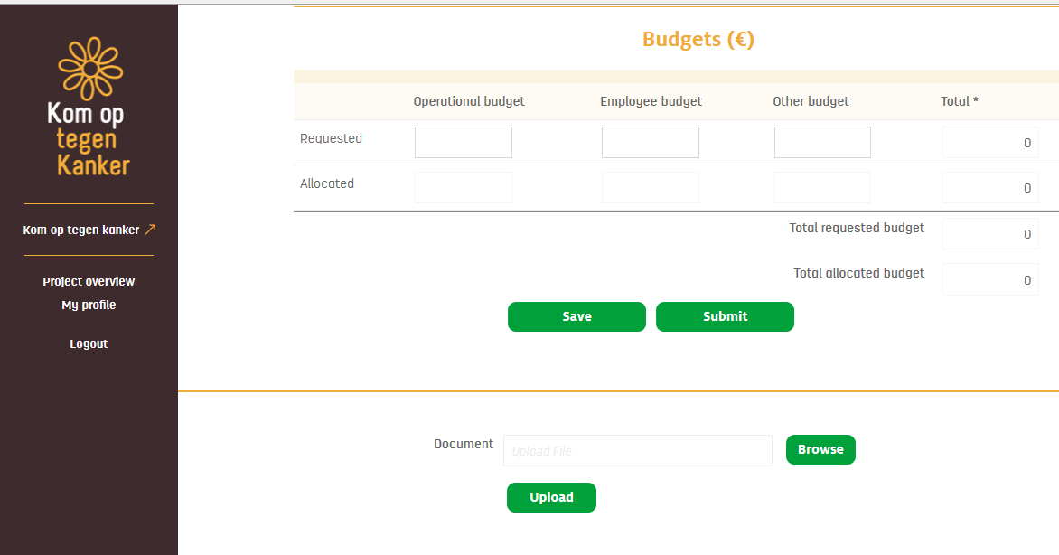
Before clicking save
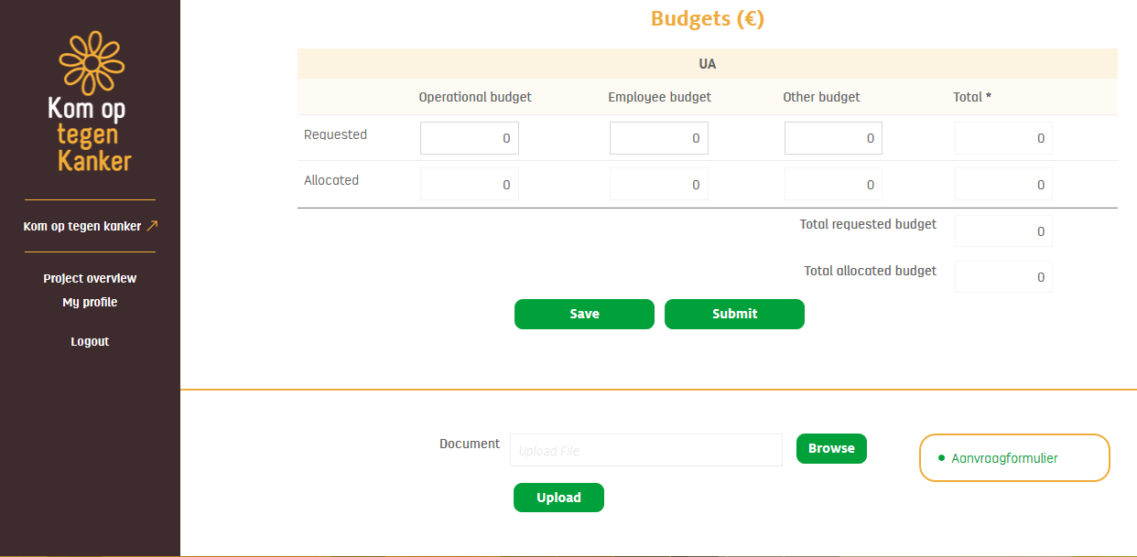
After clicking save
The application template can be downloaded by clicking on “aanvraagformulier”. This document is then saved on your computer to be further completed.
Please note: for the 2015 call in biomedical sciences, the application template is accessible even before the information is saved.
Upload: The finalised application document can be uploaded via selecting the “browse” button, selecting the document as saved on your computer and clicking on ‘open’. The name of your document should then appear in the document field. Then click on the “upload” button. The document will automatically be uploaded in the system and appear under the title “documents” on the screen (see screen shot).
Please note: only .pdf and .xls documents can be uploaded.
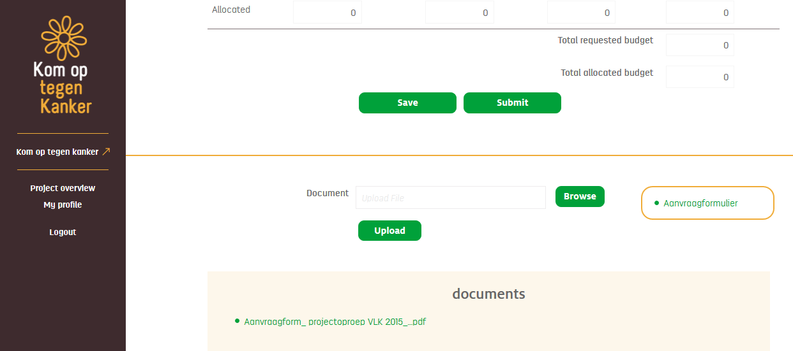

Submit: By clicking on the “submit” button your application will be officially submitted. After clicking on submit no further changes can be made without going through the project management coordinators (Ipelemans@komoptegenkanker.be and ELauwers@komoptegenkanker.be)Therefore please carefully check the information and documents for completeness and accuracy before submitting. Remember to attach the application form before clicking on “submit”.

3/ Help
If after reading this guidance you still have unanswered questions please contact the applicable project managers:
ELauwers@komoptegenkanker.be for biomedical projects
Ipelemans@komoptegenkanker.be for psychosocial and social sciences projects
We will answer your questions as quickly as possible during working hours (M-F, 8.30-17.30).

